ENGLISH FIRST ADDITIONAL LANGUAGE
GRADE 8
12 NOVEMBER 2012
PAPER 1 – LANGUAGE
TIME: 1½ Hour (9:40 – 11:10)
INFORMATION
- This paper consists out of:
Section A – Comprehension (20)
Section B – Summary (10)
Section C – Language (20)
- You are writing: EFAL Paper 1, November 2012
INSTRUCTIONS
- Leave 3 LINES open at the top before you write your Name, Surname, Grade and Section.
- Begin the answers of each SECTION on a new page.
- Leave a line OPEN between answers.
- Leave a 2cm-wide margin on the right-side of the page for marks.
- Write neat and LEGIBLY.
- Staple your answers to the front of your question paper when you hand in.

SECTION A -Comprehension (20)
Read the following passage and answer the questions that follow

The teens and dating debate: What is the right age?
- "One of the more unpleasant experiences of parenthood is dealing with your teenager's retorts: 'All my other friends' parents let them...fill in the blank'," says psychologist and clinical social worker Dr. Leslie Beth Wish. "For teens, one of the earmarks of independence is being able to go out on dates -- preferably without your parents."

so, What's the right age?
2. Your teen might want to date, but is she ready? "Sixteen-- and even a bit older -- is a good age for dating, provided that the teen is mature," says Dr. Wish. "Maturity can be measured by willingness to participate sufficiently in household chores, treating others with respect, getting good grades and managing emotions.'"
3. Mike Domitrz, parent of two teenagers and the author of, HELP! My Teen Is Dating: Real Solutions to Tough Conversations, says that 16 is the ideal age. "Almost EVERY teenager plans on being intimate with his/her partner (whether they admit it to you or not) in some form -- from kissing to potentially much more. In the majority of states, your teen cannot give legal consent to any intimacy until he/she is 16. Do NOT put your child into a situation which is inappropriate for him/her," he says.
4. "The problem that most parents make is waiting too late to allow their children to date," says Dr. Donna Thomas-Rodgers, who suggests allowing teens to go to group dances and supervised events at age 14, allowing them to go on group dates at age 15 and individual dates at age 16.
5. "When teens start at 15 years old with actual group dating you can support the child's dating choices and supervise their decisions," she says. "I saw it all throughout college. Those with very strict lives went wild in college. When you have more time with them while they are at home they don't feel the need to go overboard once they leave the nest."

Supervised versus Unsupervised dating
- How much supervision should you give your teen on dates and other parties? "Some dating situations are just screaming for supervision," says Dr. Wish. "Prom night, Halloween parties, etc. should be supervised! Some parents have the following rules: No parties at homes that don't have parental supervision. No overnights or late-night parties. Wise parents do NOT aim to be liked or popular."
- Bert Martinez, father of five children, said he doesn't allow unsupervised dates until the kids are 18, allowing only chaperoned or group dates at age 16.
- "Remember our kids, just like we did, are fighting hormones, peer pressure, and powerful emotions. Make it easier on them by setting up rules in advance to help them get through the next few years," he says.

  - Say whether the following statement is TRUE or FALSE. Quote part of a sentence to support your answer.

Parents like it when their children want to date at a young age.
(2)
1.2 Say whether the following statement is TRUE or FALSE. Quote part of a sentence to support your answer.

The best age to start dating, is 14.
(2)
1.3 The article is about teenagers in which country?
(1)
1.4 Name two qualities teenagers should show before they should be allowed to date.
(2)
1.5 Why is it almost impossible to date properly before the age of sixteen?
(2)
1.6 What do you think is a “supervised date”? (par. 6, 7 and 8)
(2)
1.7 Explain what the “horse dance is” in your own words. Pa
(2)
1.8 What is implied with the term “went wild”? (par. 5)
(1)
1.9 Pretend you are a parent and your 13 year old wants to date and 18 year old. Give two reasons why you will allow or not allow it.
(2)
1.10 “Some dating situations are just screaming for supervision”. Is this statement meant literally or figuratively? Give a reason for your answer.
(2)
1.11 Why do you think is it important that parents don’t try to be popular with their kids or even liked? (par. 6)
(1)
1.12 During the ages 12-16 children have to cope with fighting hormones, peer pressure and ________ __________. Write down the missing words. (par. 8)
(1)
[20]
GO TO NEXT PAGE

Section B Summary (10)
QUESTION 2
Read the article below about Teens and Dating. Pretend you are a parent with a teenagers who wants to date at a too young age. Write down which seven tips you would use from Dr. Phil to help you in your situation. Use exactly 60 words. Indicate the number of words in brackets. List your tips nr. 1 -7.
(10)

Teens and Dating
How young is too young? Dr. Phil says that teenagers, especially younger pre-teens, don't need to have boyfriends and girlfriends. Still, he knows that young relationships do form. Here is his advice for parents:
Teenagers shouldn't have serious dating relationships. No 14-year-old needs to have an intense boyfriend or girlfriend. Encourage group dates supervised by an adult.Don't allow your teenager to close the bedroom door when someone of the opposite sex is over. This should be a non-negotiable rule.Talk with your teenager. The more conversations you have, the less likely he/she will be to get into trouble. If you've always kept the door open for discussions, your child will be more likely to come to you with questions or problems. If you're too oppressive and restrictive, you are guaranteeing rebellion. Use logic and reason when creating rules for your teenager.Don't just forbid certain activities, explain why you forbid them. Doing this will help your teenager understand that you're not merely trying to be bossy or imposing arbitrary rules.
GO TO NEXT PAGE

Section C Language (20)

Question 3 Cartoon (5)
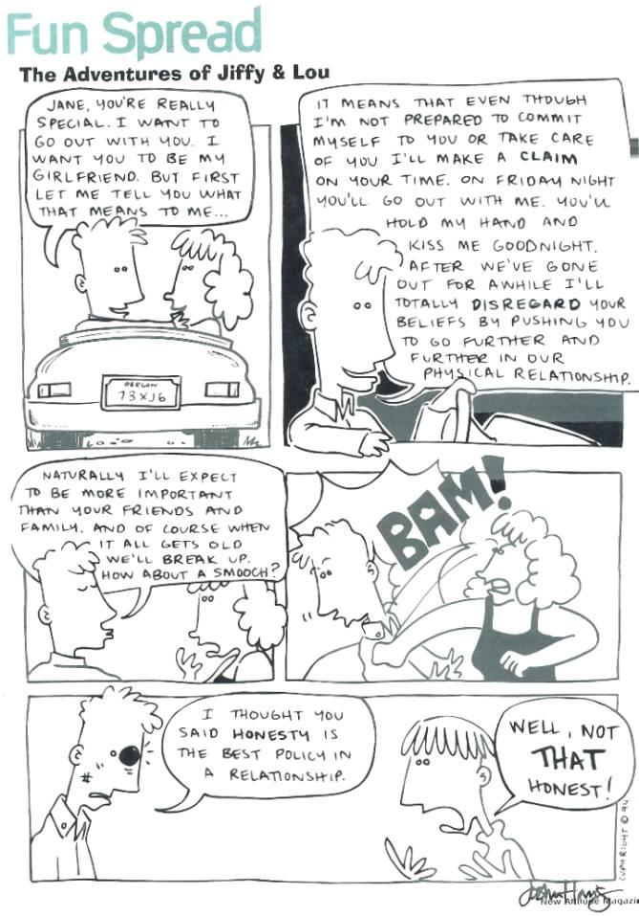

3.1 How do you think the girl feel about the words being spoken in frame 1?
(1)
3.2 What is the meaning of the word “smooch” (Frame 3)?
(1)
3.3 What unacceptable promises does the boy make? Name TWO.
(2)
3.4 How do you know the girl is very unhappy with everything the boy said?
(1)
[5]

Section D - Advertisement (5)
Question 4


4.1 What is this advertisement trying to prevent?
(1)
4.2 Explain why the picture in this advertisement is very effective?
(1)
4.3 Who can you contact to find out more about this advertisement?
(1)
4.4 How does the picture in this advertisement support the phrase “Your baby is not a baby anymore”?
(2)
[5]
SECTION E – Editing (10)
Question 5

Refer to the passage that follows to answer the language questions

- Research has shown that teenagers don't get enough sleep at night and go to school tired.
- Some experts believe the cause is biological.
- Others believe that teenagers stay up late because of adolescent distractoins.
- Early high school start times can also contribute to teens' tiredness.
- This article explore will possible causes solutions and to this problem.
- Research shows that teens need eight to nine hours of sleep at night, as compared with eight hours needed for adults.
- However, they are not getting enough sleep.
- A recent study at Drexel University of students aged 12 to 18 found that "20 percent of those studied got the recommended eight or more hours of sleep during school nights with the rest getting less than eight hours.
5.1 Look at sentence 1. Write down a homophone for the word “night”.
(1)
5.2 Look at sentence 2. Change sentence 2 into a question by beginning with the word: “Do….”
(1)
5.3 Sentence 3 has a spelling mistake in it. Write down the correct spelling of the incorrect word..
(1)
5.4 Look at sentence 4. What do you call the punctuation mark used in the word “teens’”? Give a reason why the punctuation mark is used.
(2)
5.5 Look at sentence 5. There is something wrong with the word order. Write the sentence down correctly. Do not add any words that are not already in the sentence.
(2)
5.6 Look at sentence 6. Use the homonym of “shows” in a sentence so that the different meaning is clear.
(1)
5.7 In sentence 7 the word “they” is used. Who does the word “they” refer to?.
(1)
5.8 Look at sentence 8. Write the following number out as a word:
5.8.1 12

(1)
(10)
GRAND TOTAL: 50

